# introduction

We are a marketing company located in Dubai, UAE. We toke the exclusive rights to use Dubai metro stations to advertise our customers.

## problem

As our focus group is local business owners and venues, we need to define our target customers based on their location near every metro station.

Not all the metro stations areas are similar to each other’s when we check its business hot areas, as some areas have more hotels, other areas have shopping malls or parks ... etc.

Some metro stations are busier than others, so this should be considered in the pricing of the advertise especially in the peak hours of the station.

AS an expansion of our business areas as a company, in co-operation with Foursquare.com , we will start building a recommendation system based on venues visited in the station’s area.

## assumption

We will use some open datasets and APIs to collect data about metro stations and the nearby venues and targeted customers.

Moreover, we could collect some useful data about the traffic transaction of the metro stations, thanks to Dubaipulse.com.

Once we have our data ready, we will start categorizing the venues to reduce the number of business areas categories.

Then, we will build some statistics on the available data to satisfy out business needs and help the decision makers to create the right strategy.

Finally, we will start building our user recommendation system using foursquare.com APIs.

# Data sources

Finding open datasets now becomes easier than before, we used one dataset provided by Dubai government and another one found on Github.com then we used a public API from Foursquare.com.

## Dubai neighborhoods dataset

About Dataset

A dataset which contains neighborhood name along with its latitude and longitude.

Source

[Github.com](https://gist.github.com/amlapierre/1cef140b0315a32778e4ecdde78b4b0a#file-dubai_neighborhoods-csv)

Sample response

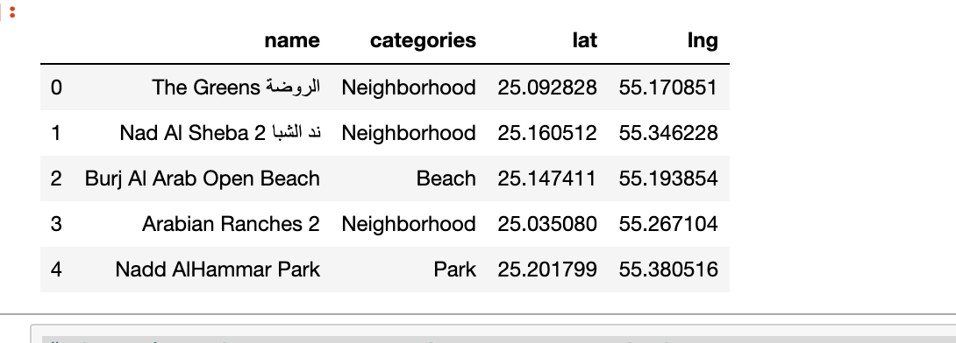

## Dubai metro stations dataset

About Dataset

A dataset which contains metro stations name and metro line along with its latitude and longitude.

Source

[Dubaipulse.gov.ae](https://www.dubaipulse.gov.ae/data/rta_metro_stations-open/datafiles/ac7932e2-63c7-4780-9c87-2de1c114d732/rta-rail?organisation=rta&service=rta-rail#preview)

Sample response

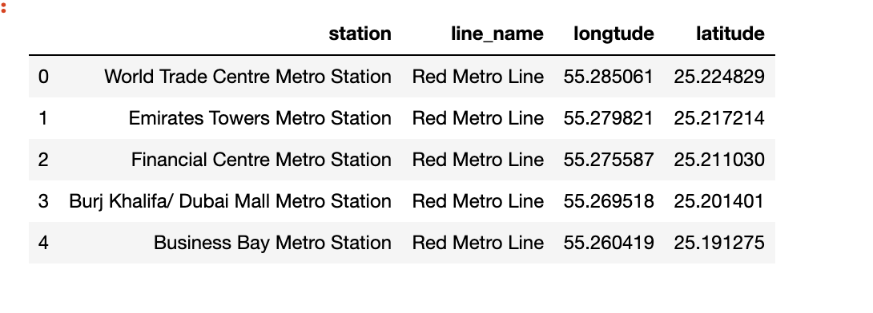

## Nearby venues api

About api

Returns a list of recommended venues near the current location.

Source

[Foursquare.com](https://developer.foursquare.com/docs/api/venues/explore)

Sample response

|  |
| --- |
| {      **"meta"**:{         **"code"**:200,       **"requestId"**:"5ac51ef86a607143de8eg5cb"    },    **"response"**:{         **"warning"**:{            **"text"**:"There aren't a lot of results near you. Try something more general, reset your filters, or expand the search area."       },       **"suggestedRadius"**:600,       **"headerLocation"**:"Lower East Side",       **"headerFullLocation"**:"Lower East Side, New York",       **"headerLocationGranularity"**:"neighborhood",       **"totalResults"**:230,       **"suggestedBounds"**:{            **"ne"**:{               **"lat"**:40.724216906965616,             **"lng"**:-73.9896507407283          },          **"sw"**:{               **"lat"**:40.72151724718017,             **"lng"**:-73.98693222860872          }       },       **"groups"**:[            {               **"type"**:"Recommended Places",             **"name"**:"recommended",             **"items"**:[                  {                     **"reasons"**:{                        **"count"**:0,                      **"items"**:[                           {                              **"summary"**:"This spot is popular",                            **"type"**:"general",                            **"reasonName"**:"globalInteractionReason"                         }                      ]                   },                   **"venue"**:{                        **"id"**:"49b6e8d2f964a52016531fe3",                      **"name"**:"Russ & Daughters",                      **"location"**:{                           **"address"**:"179 E Houston St",                         **"crossStreet"**:"btwn Allen & Orchard St",                         **"lat"**:40.72286707707289,                         **"lng"**:-73.98829148466851,                         **"labeledLatLngs"**:[                              {                                 **"label"**:"display",                               **"lat"**:40.72286707707289,                               **"lng"**:-73.98829148466851                            }                         ],                         **"distance"**:130,                         **"postalCode"**:"10002",                         **"cc"**:"US",                         **"city"**:"New York",                         **"state"**:"NY",                         **"country"**:"United States",                         **"formattedAddress"**:[                              "179 E Houston St (btwn Allen & Orchard St)",                            "New York, NY 10002",                            "United States"                         ]                      },                      **"categories"**:[                           {                              **"id"**:"4bf58dd8d48988d1f5941735",                            **"name"**:"Gourmet Shop",                            **"pluralName"**:"Gourmet Shops",                            **"shortName"**:"Gourmet",                            **"icon"**:{                                 **"prefix"**:"https://ss3.4sqi.net/img/categories_v2/shops/food_gourmet_",                               **"suffix"**:".png"                            },                            **"primary"**:true                         }                      ],                      **"popularityByGeo"**:0.9999983845502491,                      **"venuePage"**:{                           **"id"**:"77298563"                      }                   }                }             ]          }       ]    } } |

## 4.venues’ likes api

About api

Get Users Who Liked a Venue

.

Source

[Foursquare.com](https://developer.foursquare.com/docs/api/venues/explore)

Sample response

|  |
| --- |
| {     **"meta"**:{        **"code"**:200,       **"requestId"**:"5854c1f8351e3d5887252266"    },    **"notifications"**:[        {           **"item"**:{              **"unreadCount"**:13          },          **"type"**:"notificationTray"       }    ],    **"response"**:{        **"like"**:false,       **"likes"**:{           **"count"**:28,          **"groups"**:[              {                 **"count"**:28,                **"items"**:[                  ],                **"type"**:"others"             }          ],          **"summary"**:"28 Likes"       }    } } |

## 5.Monthly trips numbers per metro station dataset

About Dataset

Total number of the monthly trips per metro station

Source

[Dubaipulse.gov.ae](https://www.dubaipulse.gov.ae/data/rta_metro_stations-open/datafiles/ac7932e2-63c7-4780-9c87-2de1c114d732/rta-rail?organisation=rta&service=rta-rail" \l "preview)

(One dataset per month, total number 9 datasets)

Sample response

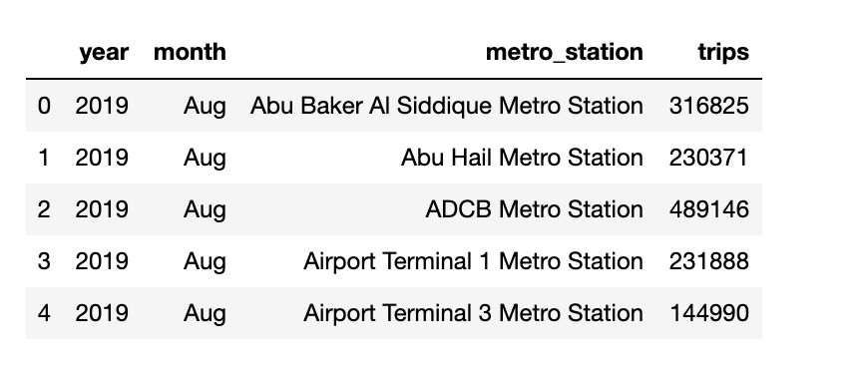

## 6.a random working day all stations check-in and check-out transactions dataset

About Dataset

All stations transactions in 27th March 2018 (Normal working day)

Source

[Dubaipulse.gov.ae](https://www.dubaipulse.gov.ae/data/rta_metro_stations-open/datafiles/ac7932e2-63c7-4780-9c87-2de1c114d732/rta-rail?organisation=rta&service=rta-rail#preview)

Sample response

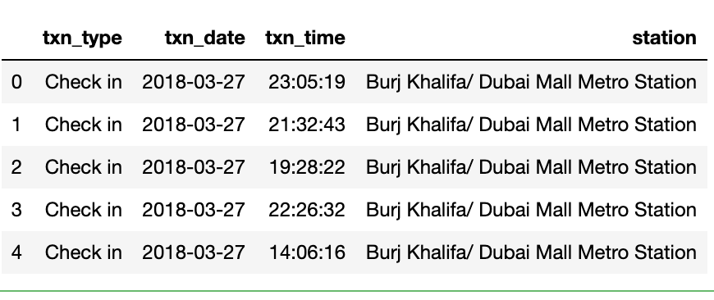

# Analysis and findings

First of all, we listed the metro stations that our analysis will be based on

* World Trade Centre Metro Station
* Emirates Towers Metro Station
* Financial Centre Metro Station
* Burj Khalifa/ Dubai Mall Metro Station
* Business Bay Metro Station
* Noor Bank Metro Station
* First Abu Dhabi Bank Metro Station
* Mall of the Emirates Metro Station
* Sharaf DG Metro Station
* Dubai Internet City Metro Station
* Nakheel Metro Station
* DAMAC Properties Metro Station
* DMCC Metro Station
* Nakheel Harbour & Tower Metro Station
* Ibn Battuta Metro Station
* Energy Metro Station
* Danube Metro Station
* UAE Exchange Metro Station
* Etisalat Metro Station
* Al Qusais Metro Station
* Dubai Airport Free Zone Metro Station
* Al Nahda Metro Station
* Stadium Metro Station
* Al Qiyadah Metro Station
* Abu Hail Metro Station
* Abu Baker Al Siddique Metro Station
* Salah Al Din Metro Station
* Union (Green Line ) Metro Station
* Baniyas Square Metro Station
* Palm Deira Metro Station
* Al Ras Metro Station
* Al Ghubaiba Metro Station
* Al Fahidi Metro Station
* BurJuman Metro Station
* Oud Metha Metro Station
* Dubai Healthcare City Metro Station
* Al Jadaf Metro Station
* Creek Metro Station
* Rashidya Depot
* Rashidiya Metro Station
* Emirates Metro Station
* Airport Terminal 3 Metro Station
* Airport Terminal 1 Metro Station
* GGICO Metro Station
* Deira City Centre Metro Station
* Al Rigga Metro Station
* Union Metro Station
* ADCB Metro Station
* Al Jafiliya Metro Station

## Nearby Venues

Using the Explore API from foursquare, we could retrieve most of the nearby venues to the metro stations.

|  |  |  |  |  |  |  |
| --- | --- | --- | --- | --- | --- | --- |
|  | **Station** | **Venue ID** | **Venue Name** | **Category** | **Lat** | **Long.** |
| 0 | World Trade Centre Metro Station | 5c18d290da7080002c9a6e83 | Opa Dubai | Greek Restaurant | 25.226190 | 55.284894 |
| 1 | World Trade Centre Metro Station | 4d3170065c2db60c9518b86c | Conrad Dubai | Hotel | 25.226089 | 55.283571 |
| 2 | World Trade Centre Metro Station | 4b0587eaf964a52090a622e3 | Fairmont Dubai | Hotel | 25.226206 | 55.284714 |
| 3 | World Trade Centre Metro Station | 564e368a498e0884971bfdc8 | Bagatelle Dubai | French Restaurant | 25.226147 | 55.284663 |

## categorizing

In order to reduce the number of categories to help in the analysis process, we started to create a main category for the venues’ categories so both of Greek Restaurant and French Restaurant will be “Restaurant”

|  |  |  |  |  |  |  |  |
| --- | --- | --- | --- | --- | --- | --- | --- |
|  | **Station** | **Venue ID** | **Venue Name** | **Lat** | **Long** | **Category** | **Main Category** |
| 876 | UAE Exchange Metro Station | 5624b50d498e469eb77ddad9 | Taqado Mexican Kitchen | 24.980252 | 55.093491 | Mexican Restaurant | Restaurant |
| 857 | UAE Exchange Metro Station | 563095d6498ea09d5435fd44 | Joga | 24.980279 | 55.093656 | Salad Place | Restaurant |
| 1235 | UAE Exchange Metro Station | 536b469d498e308b4748fe87 | 1762 | 24.980698 | 55.093846 | Deli / Bodega | Restaurant |
| 258 | UAE Exchange Metro Station | 4e10288c8877ac23b655c6a4 | Oregano | 24.981092 | 55.093726 | Italian Restaurant | Restaurant |
| 338 | UAE Exchange Metro Station | 4e77053fe4cd32543800227e | Canteen L'Oreal ME | 24.981446 | 55.092854 | Restaurant | Restaurant |

By grouping the Categories we found that the most popular business areas in Dubai are the following

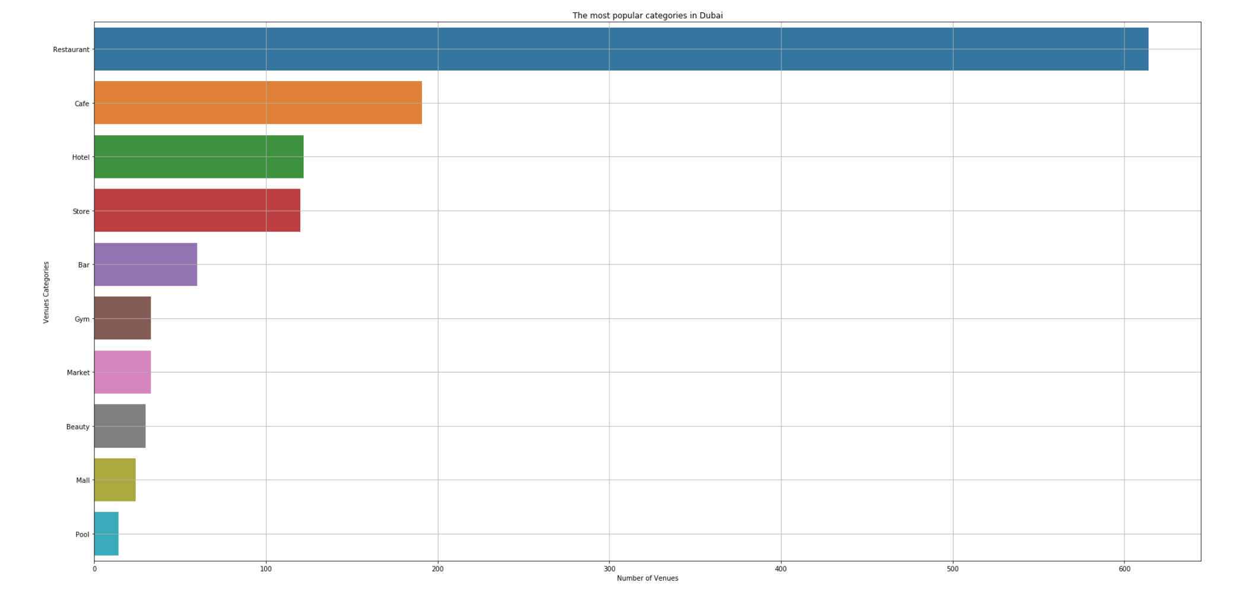

|  | **Category** | **Number of Venues** |
| --- | --- | --- |
| 0 | Restaurant | 614 |
| 1 | Cafe | 191 |
| 2 | Hotel | 122 |
| 3 | Store | 120 |
| 4 | Bar | 60 |
| 5 | Gym | 33 |
| 6 | Market | 33 |
| 7 | Beauty | 30 |
| 8 | Mall | 24 |
| 9 | Pool | 14 |

## hot business areas

Restaurants are coming in the first place then Cafes, Hotel and General Stores. But is this popularity are shared among all the metro stations areas?

To have more insight to the metro station popular or hot business areas, we grouped both of Station and Main Category data and found the following sample:

|  |  |  |  |
| --- | --- | --- | --- |
|  | **Station** | **Main Category** | **Number of Venues** |
| 0 | ADCB Metro Station | Restaurant | 27 |
| 1 | ADCB Metro Station | Hotel | 4 |
| 2 | ADCB Metro Station | Cafe | 3 |
| 3 | Abu Baker Al Siddique Metro Station | Restaurant | 11 |
| 4 | Abu Baker Al Siddique Metro Station | Hotel | 4 |

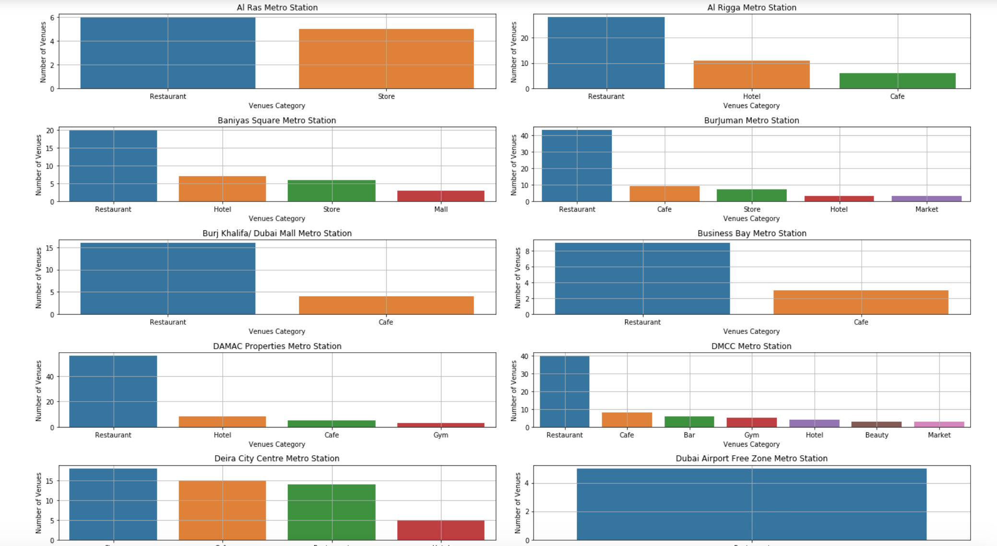

## Gender based categorizing

One more useful classification, checking if there some business categories are more preferred to a gender more than the other?

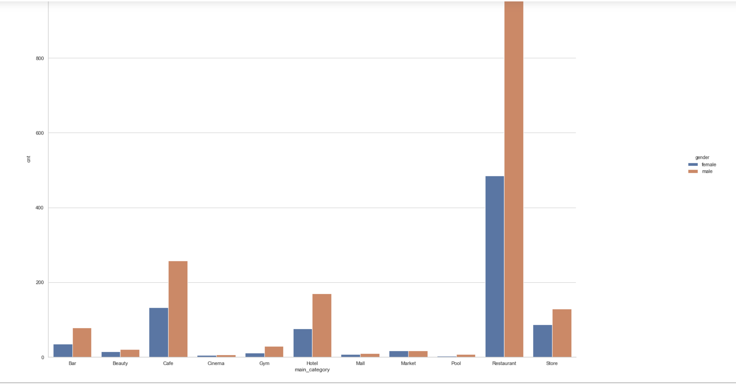

We found that venues like Restaurants, Cafes and Hotels have ore check-ins for males than females, but venues like Markets, Stores and Beauty related venues are almost have the same popularity for both of the genders.

## Gold class customers

In order to check the Gold class venues based on their popularity, we did the following statistic based on foursquare.com Likes API

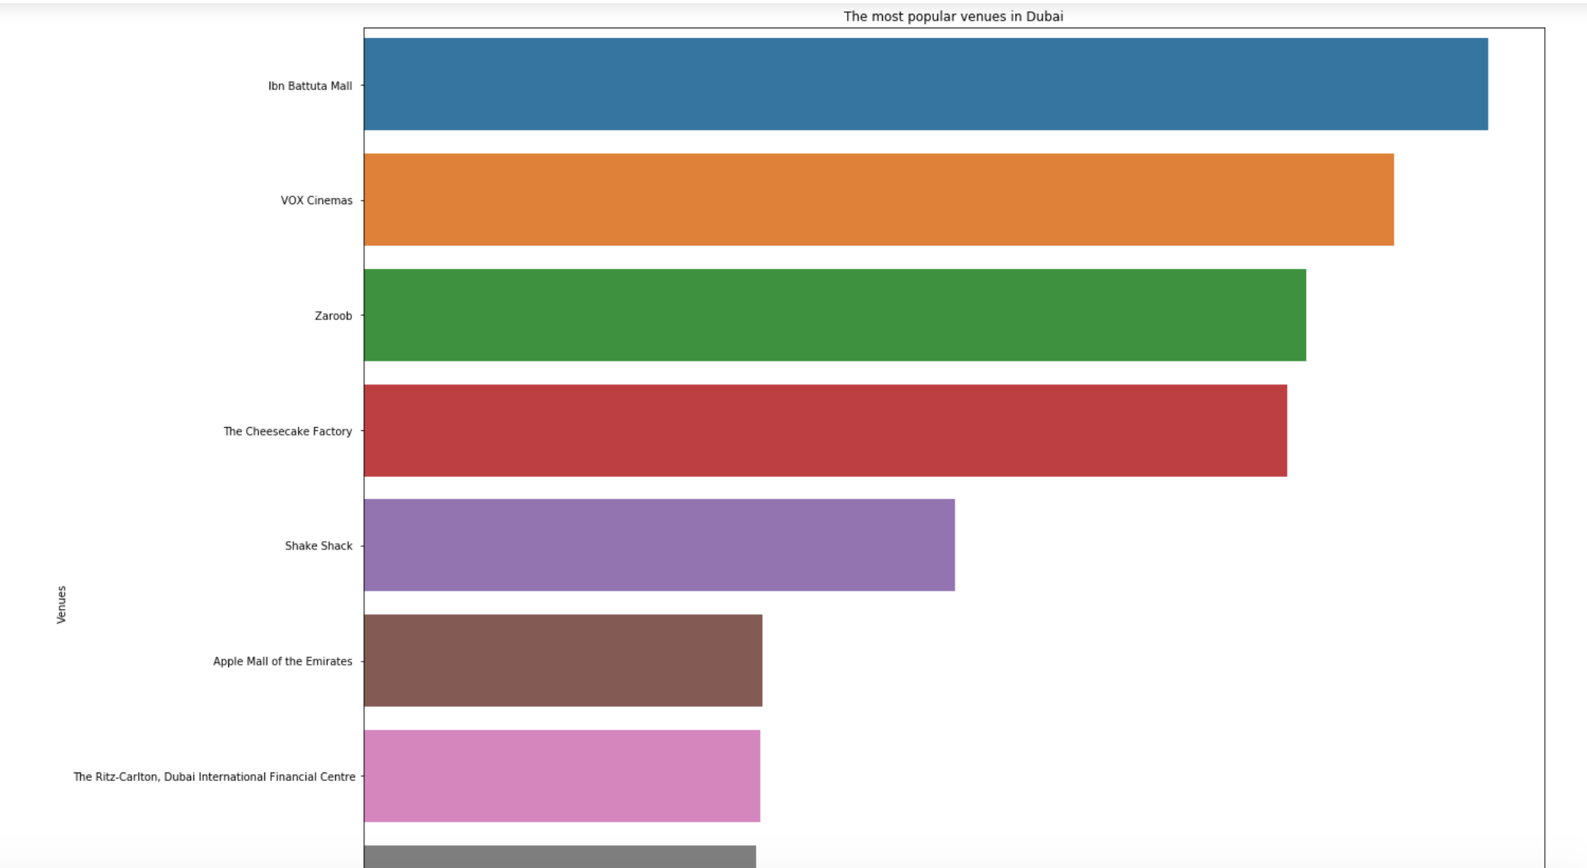

## Stations’ Trips and classification

Picking the number of monthly transaction, we found that the most crowded metro stations can be as following

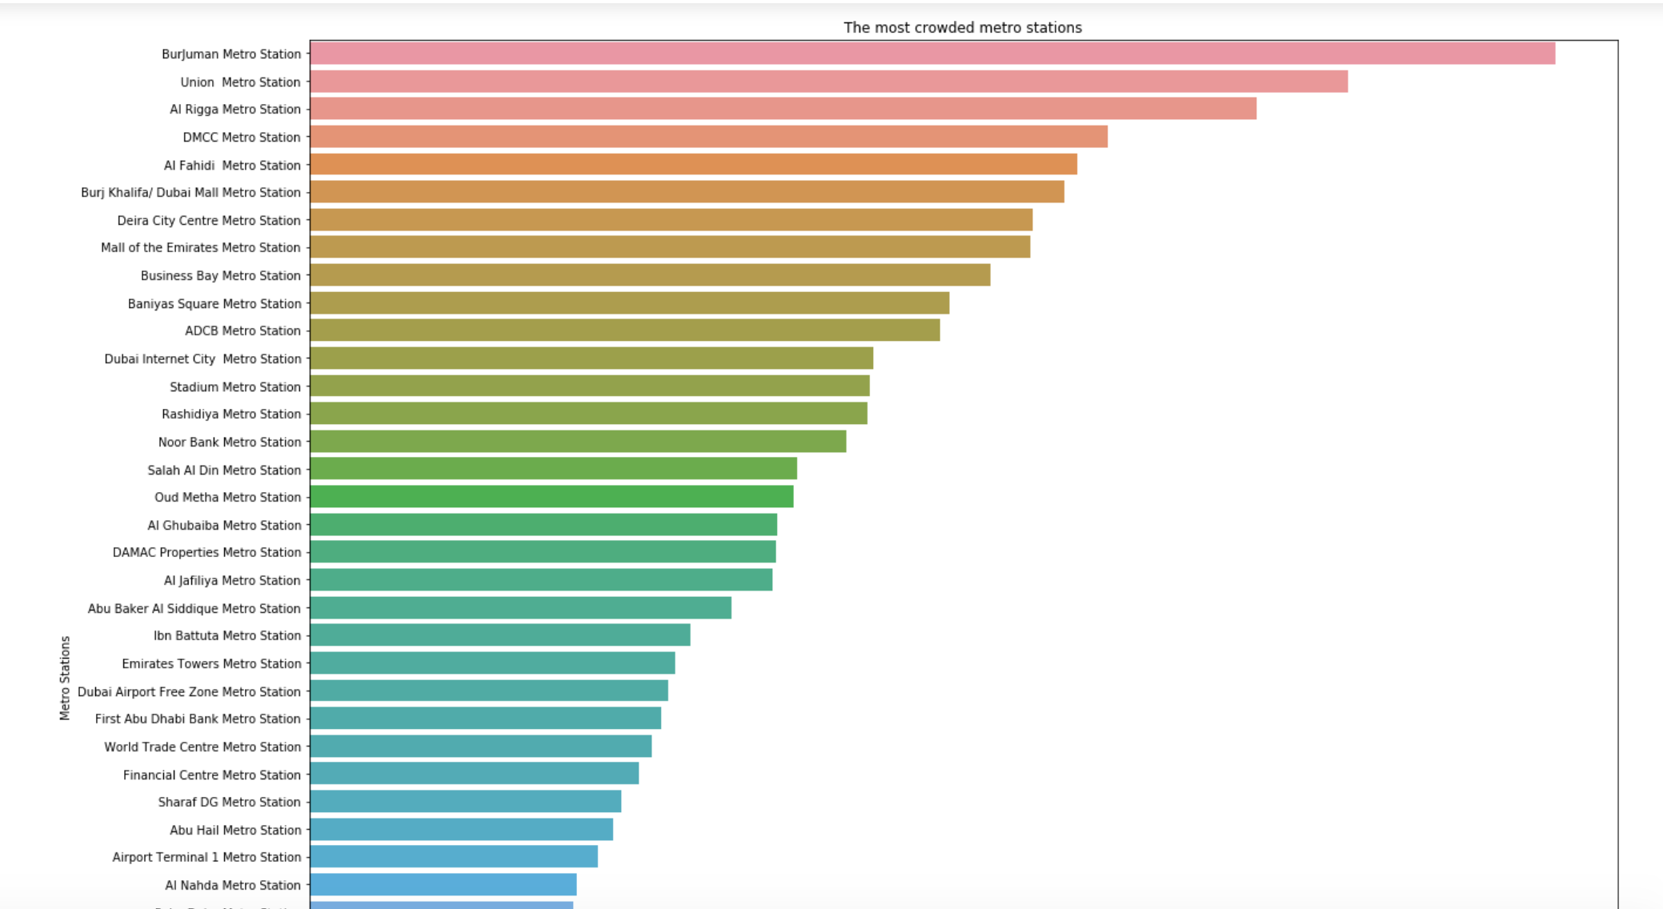

So based on the previous figure, we can categorize the metro stations from A to D based on the number of transactions.

| **Station** | **Number of Transactions from Jan 2019 to Aug 2019** | **Category** |
| --- | --- | --- |
| ADCB Metro Station | 527789 | B |
| Abu Baker Al Siddique Metro Station | 353043 | C |
| Abu Hail Metro Station | 254428 | D |
| Airport Terminal 1 Metro Station | 241753 | D |
| Airport Terminal 3 Metro Station | 151413 | D |

In [66]:

## Peak hours

Advertising price can’t be the same comparing the peak hours with normal ones, so we need to calculate the peak hours of the metro stations in order to set the pricing for the digital boards’ rental.

Picking a random working day’s (27th March 2018) check-in and check-out transactions, we were able to create the following charts.

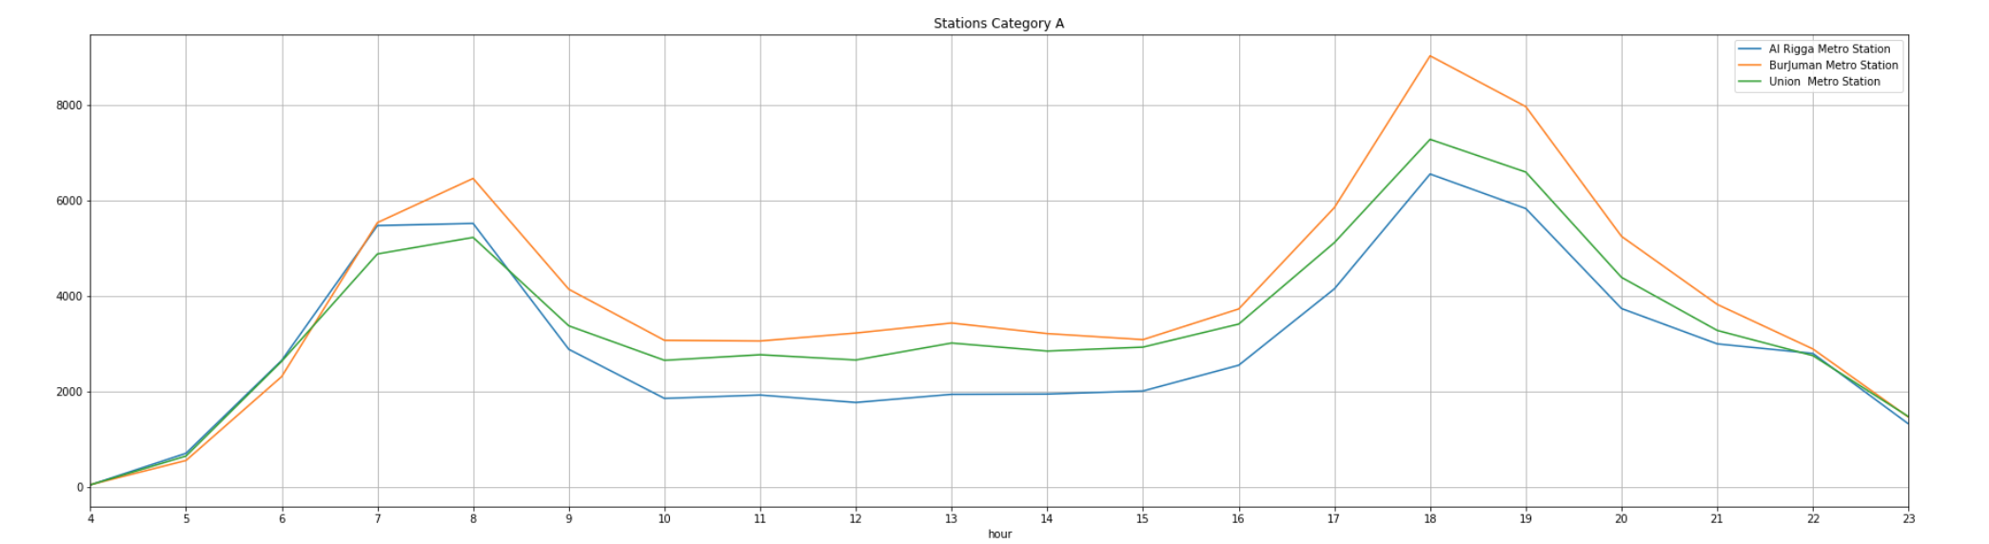

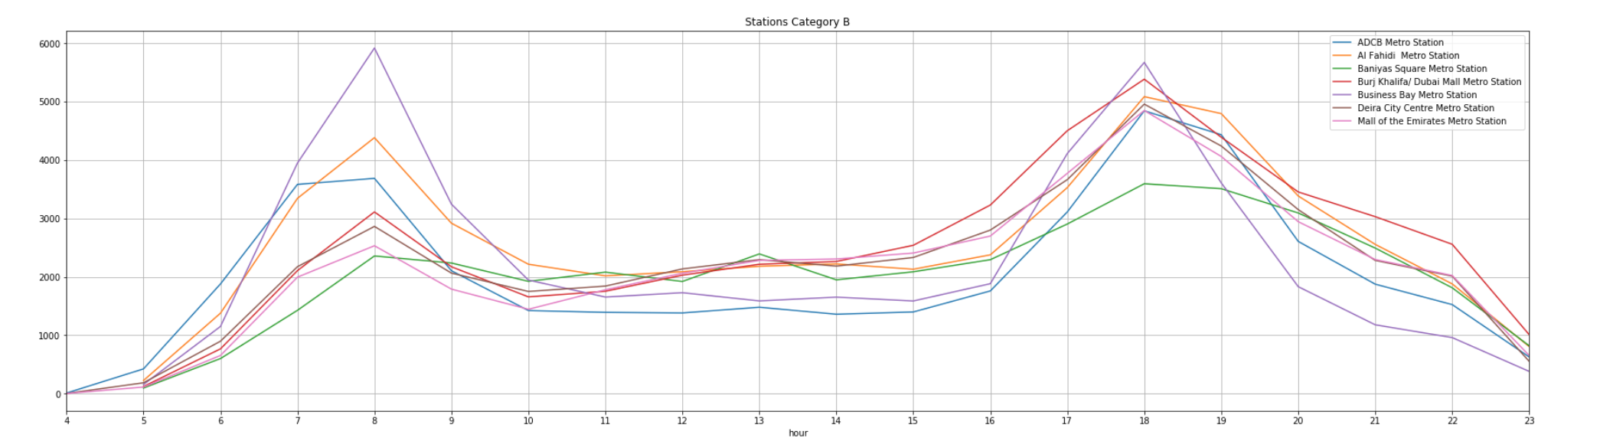

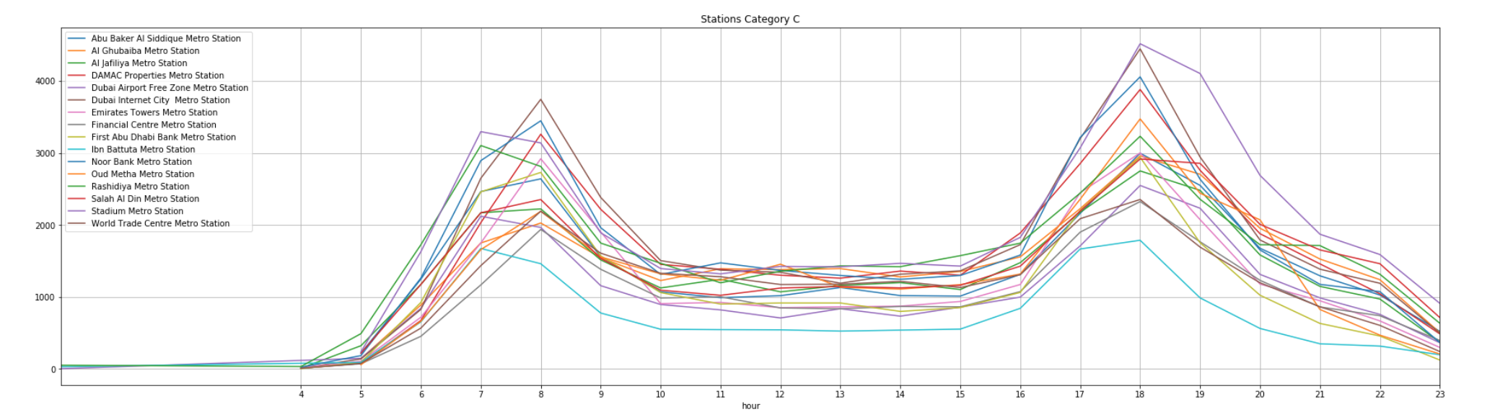

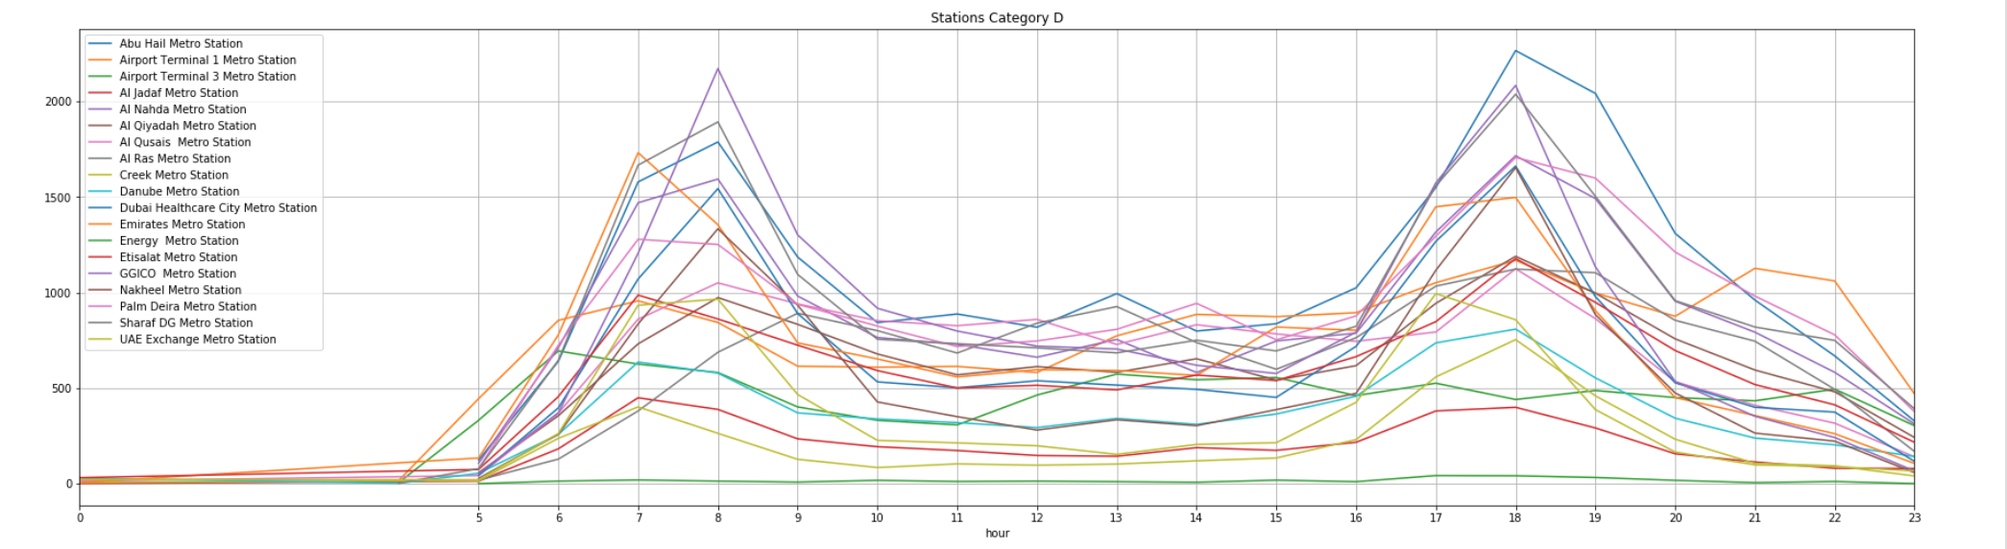

The peak hours for most of the stations are between 7:00 am: 8:00 am and 5:00 pm: 7:00 pm, so this could be considered in the pricing process.

## High/Low season

The following chart shows the number of transactions per month, it shows that summer months has less traffic than winter (Transactions are in Million)

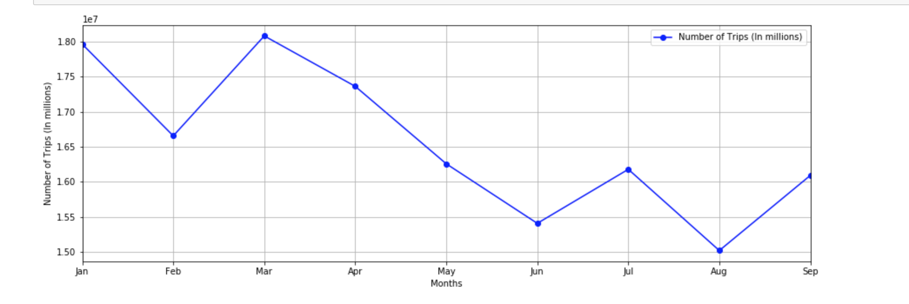

## Geographical distribution

One more information will be an added value in order to see the whole picture, the geographical distribution of the stations’ categories (A, B, C and D).

The following map show the geographical distribution of the stations’ categories.

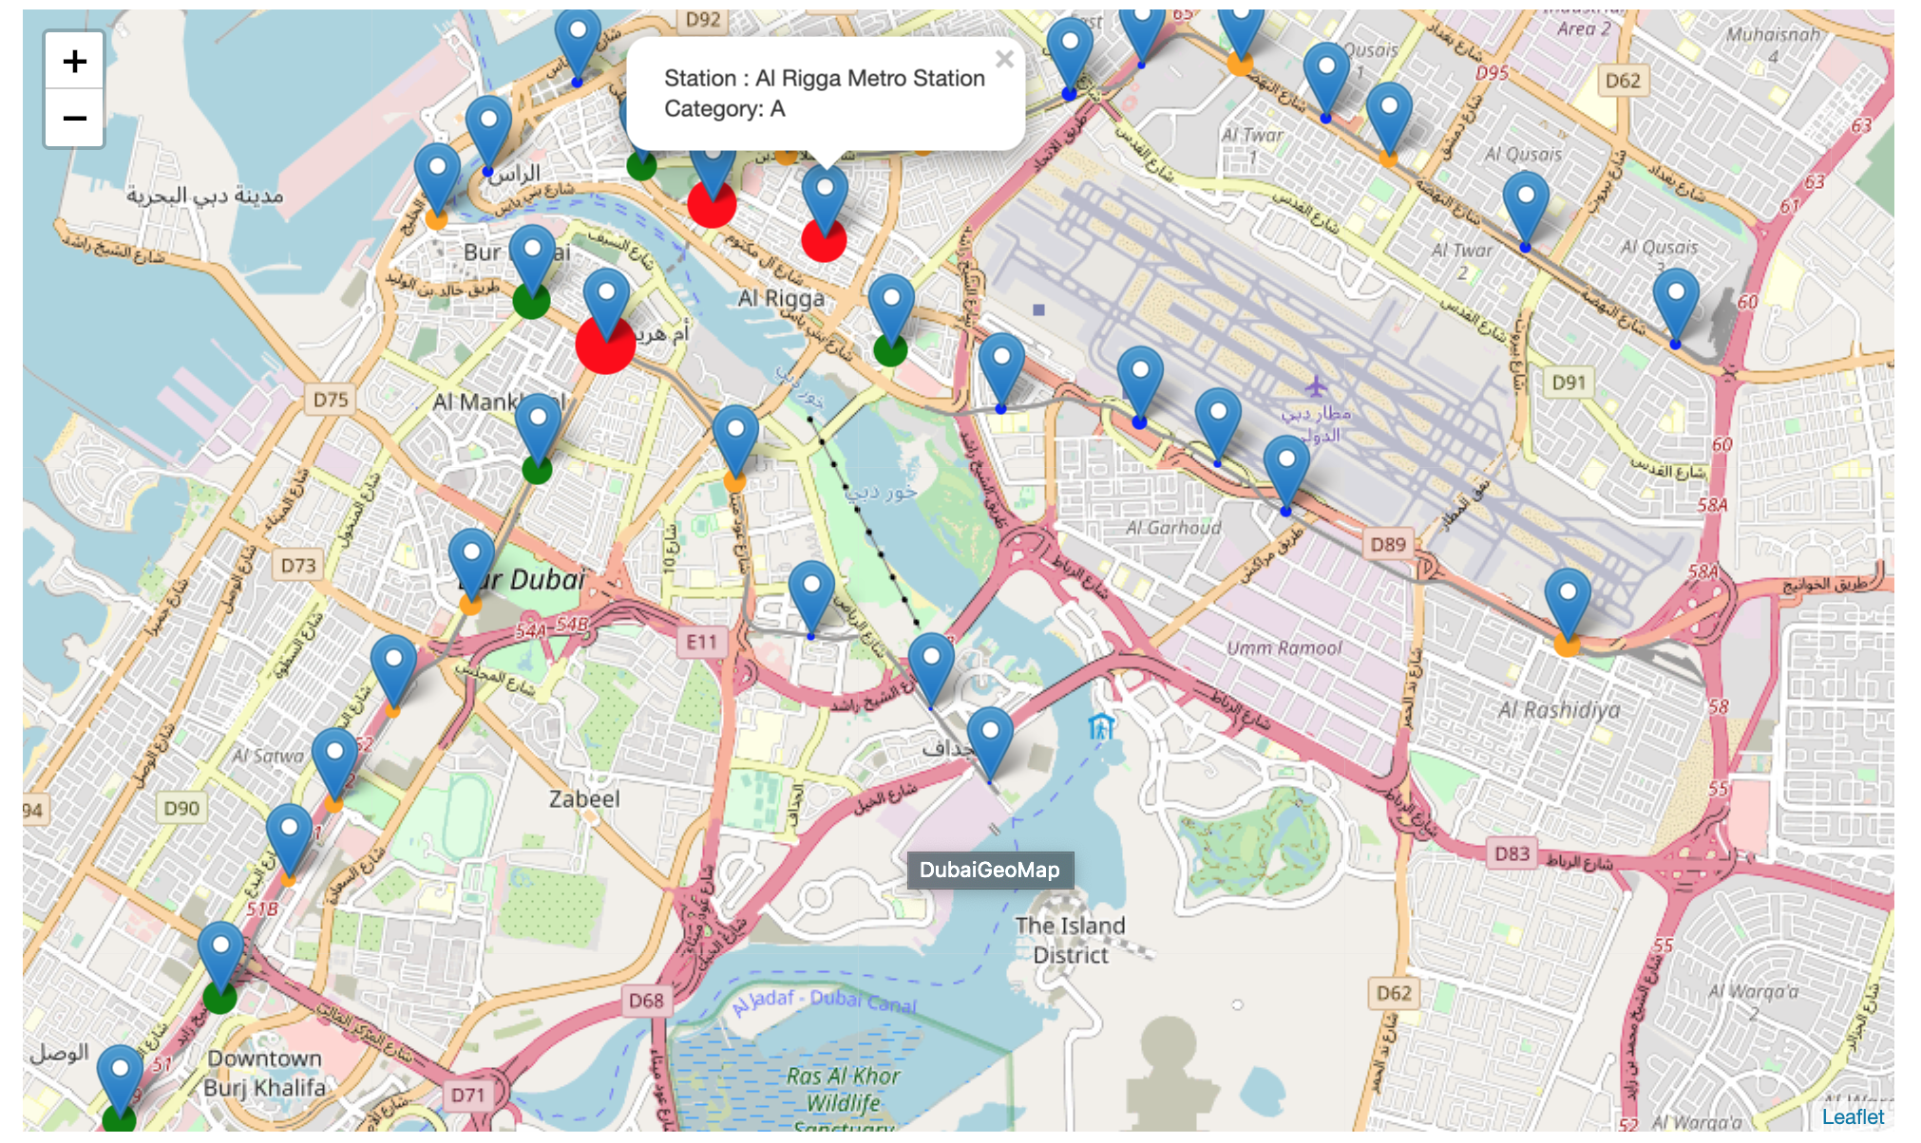

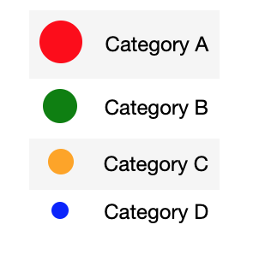

Conclusion

Stations like Al Rigga, Burjuman and Union metro station can be classified as Category A as they are the most visited station among the other stations and this will be considered in the advertising pricing process.

Number of passengers reaching its minimum in July and summer months, so we may reduce the price for advertising in those months.

The peak hours for most of the stations are between 7:00 am: 8:00 am and 5:00 pm: 7:00 pm, these will be the attractive hours for the customers that need their ad be viewed by the largest number of passengers.

Restaurants, hotels, stores and cafes have the largest number of venues around Dubai.

Venues like Ibn Battuta mall, Zaroob, Vox cinemas and cheesecake factory are the most liked venues based on foursquare.com API’s data, so those could be good targeted customers.

Recommendation system

As part of the future business areas the company want to invest in, we need to build a recommendation system based on foursquare users data to start suggesting venues to the user based on venues he visited.

We will user the Content Based methodology to build the recommendation system

System will start recommending venues based on other users’ liked venues and the user liked the venue which our user currently liked.

Of course, the venue’s category will be considered as the system will not recommend a hotel to a user that liked a junk food restaurant.

Before starting the suggestion process, the system will calculate the weight of every venue based on its popularity among other venues in the same area.

In our example the system suggesting venues to users who liked Burger King near ADCB Merto Station.

The system will filter the users who liked the same venue

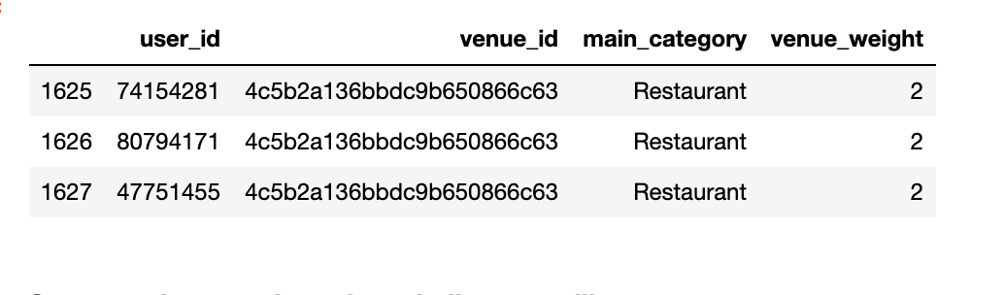

System will start recommending the popular venues which liked by the filtered users in the same category, sorted by popularity.

